Advantages of using online software.
Online documents are used often in work places; they store individual work onto the web allowing other people in the work place to access and change and delete their work. This is very beneficial as instead of emailing or sending work individually which would take a long time, anyone permitted to do so can access the work completed by employees. It also creates space on the memory of the computers as it is all stored on ‘the cloud’ for anyone to use. You can access this via your tablet or smartphone as long as you have internet access which makes it easier and quicker than having to log on to a computer and find the file, when you can just open up your phone and get onto the file like that. ‘The cloud’ backs up your work frequently so you never lose any progress.
Software using this online ‘cloud’ service are Microsoft office live, live documents, Google docs and many more.
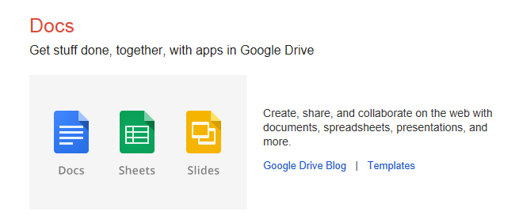
The cloud is an online storage service which can store unlimited amounts of documents, pictures and music. This is one of the things that make this idea so much better, instead of having to save things on your hard drive or memory stick; you can now save anything and everything on the cloud, and access it anywhere in the world. (With internet access)

